***Name:- Israa Ragab Okil***

***section:- (2)***

***=============================================***

**Q1: Calculate the time for each process, define the priority?**

**Answer :**

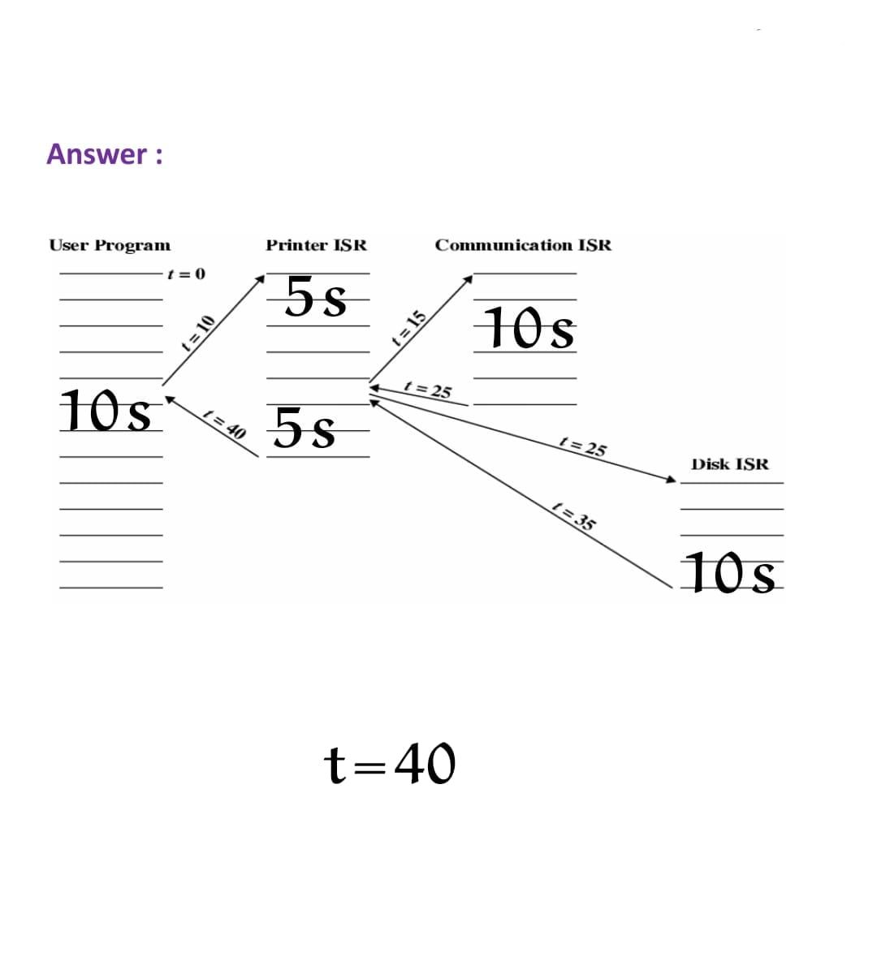 A:-

The priority :- the time :-

1. User program 10 s
2. Printer ISR 5 s
3. Communication ISR 10 s
4. Disk ISR 10 s
5. Printer ISR 5 s